
Company
Logotype

Cone Beam Computed Tomography- Report



Porur Dental X-rays & CBCT

Patient Name : Mrs. Selvakumari | Date of Report : 01.09.2024
Age/ Gender : 42 years/ Female | Region of Interest : CBCT Full Skull
Referring doctor: Dr. Praveena | Indication : Implant assessment
Clinical Notes: Nil
PATIENT INFORMATION

CBCT- Full Skull provided
CBCT – IMAGE DETAILS

RADIOGRAPHIC INTERPRETATION

- Complete loss of crown and root structure in relation to 11, 12, 13, 14, 15, 16, 17, 21, 22, 25, 26, 27, 33, 37, 45, 48.
- Generalized bone loss extending upto and beyond the apical third of all the teeth is evident.
- The alveolar ridge in relation to the maxillary and mandibular alveolar ridge is present with normal trabecular pattern.

IMPLANT ASSESSMENT

 | 11 region | 12 region | 13 region | 14 region | 21 region | 22 region | 23 region | 24 region
Sub-Crestal | 5 | 5.6 | 4.5 | 4.5 | 3.5 | 3.9 | 7.5 | 6.1
Mid- Crestal | 7.4 | 6.5 | 5.8 | 5.9 | 5 | 5.3 | 9 | 6.1
Distance between the alveolar ridge and Floor of the Nasal cavity (in mm) | 5.6 | 4.7 | 5.6 | 6.4 | 6.1 | 5.2 | 8.4 | 7.8

 | 15 region | 16 region | 17 region | 25 region | 26 region | 27 region
Sub-Crestal (in mm) | 5.2 | - | - | - | - | -
Mid- Crestal (in mm) | - | - | - | - | - | -
Distance between the alveolar ridge and floor of the maxillary sinus (in mm) | 3.7 | 1.9 | 1.2 | 2 | 1 | 1

 | 31 region | 32 region | 33 region | 34 region
Sub-Crestal (in mm) | 5.2 | 4.4 | 3.1 | 6.4
Mid- Crestal (in mm) | 4.9 | 4.7 | 5.1 | 7.5
Distance between alveolar ridge and the inferior border of mandible (in mm) | 23.2 | 22 | 21.9 | 17.4

 | 41 region | 42 region | 43 region | 44 region
Sub-Crestal (in mm) | 4.3 | 4.8 | 7.6 | 12.6
Mid- Crestal (in mm) | 4.3 | 5.8 | 9.3 | 11.6
Distance between alveolar ridge and the inferior border of mandible (in mm) | 19.6 | 19.2 | 13.9 | 14.5
 | 45 region | 46 region | 47 region
Sub-Crestal (in mm) | 9.3 | 10.9 | 10.3
Mid- Crestal (in mm) | 9.6 | 10.9 | 11.3
Distance between alveolar ridge and the inferior alveolar nerve canal (in mm) | 5.4 | 6 | 8.9
Distance between alveolar ridge and the inferior border of mandible (in mm) | 17 | 15.8 | 16.5

 | 35 region | 36 region | 37 region
Sub-Crestal (in mm) | 8.2 | 9.3 | 9.5
Mid- Crestal (in mm) | 9.5 | 9.4 | 10.4
Distance between alveolar ridge and the inferior alveolar nerve canal (in mm) | 5.7 | 7.4 | 8.7
Distance between alveolar ridge and the inferior border of mandible (in mm) | 20.5 | 16.9 | 15.9

RADIOGRAPHIC IMPRESSION

- Partially edentulous maxillary and mandibular arch.
- Generalized Chronic Periodontitis.

Kindly correlate with clinical findings


IMAGES FOR REFERENCE

RECONSTRUCTED PANORAMIC VIEW
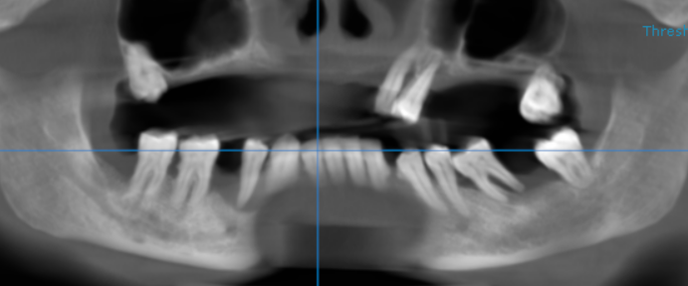

3-DIMENSIONAL VIEW
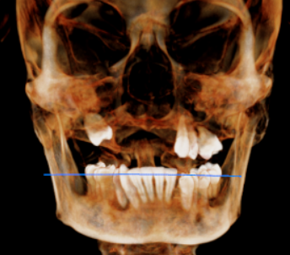

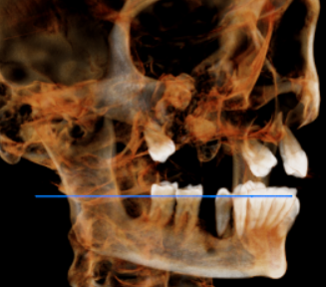
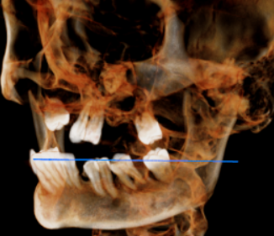

CROSS SECTIONAL VIEW

11 region | 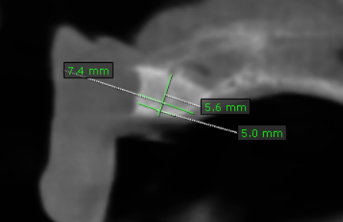
12 region | 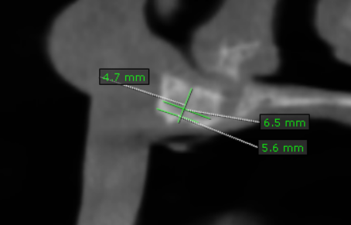
13 region | 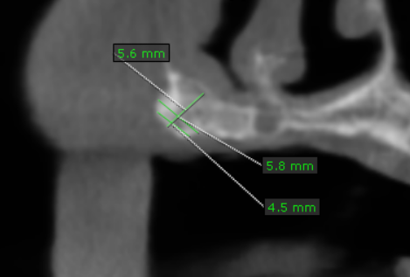
14 region | 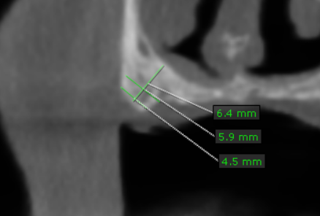
15 region | 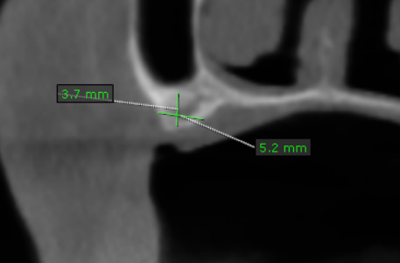
16 region | 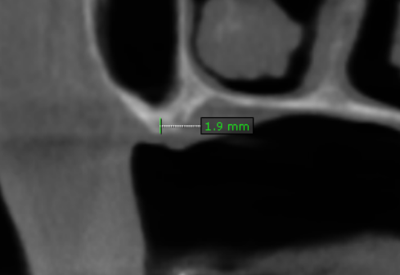
17 region | 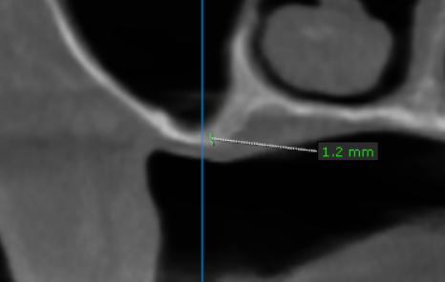
21 region | 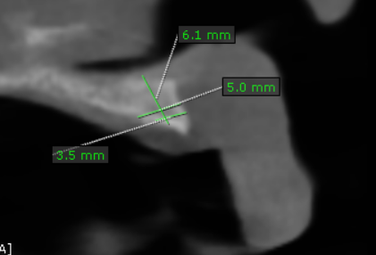
22 region | 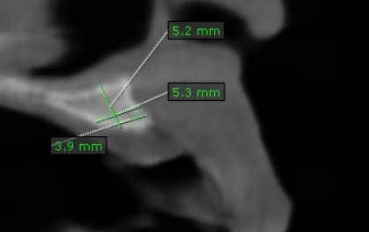
23 region | 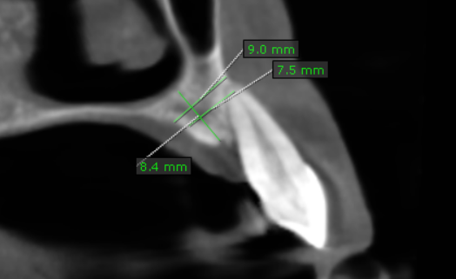
24 region | 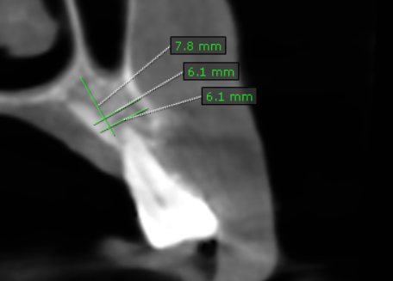
25 region | 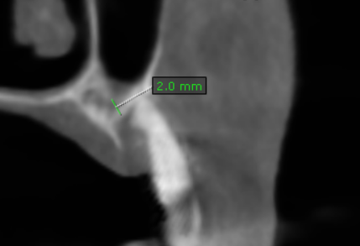
26 region | 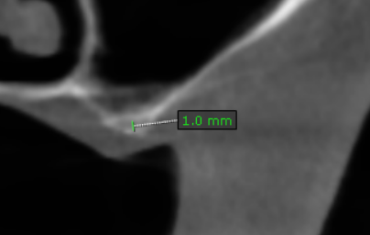
27 region | 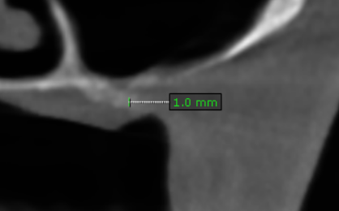
31 region | 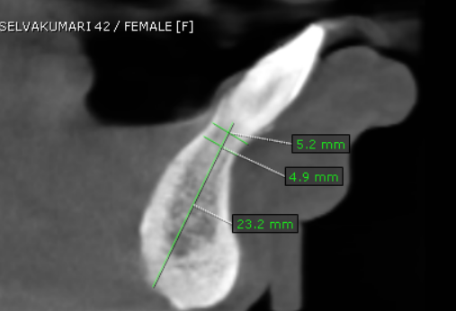
32 region | 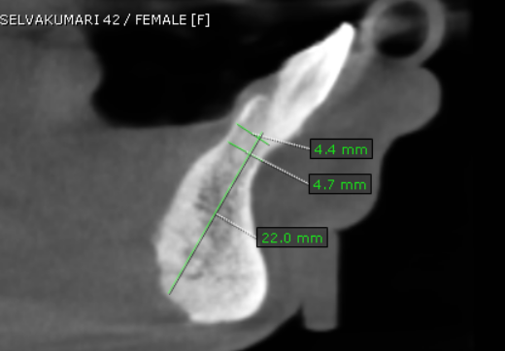
33 region | 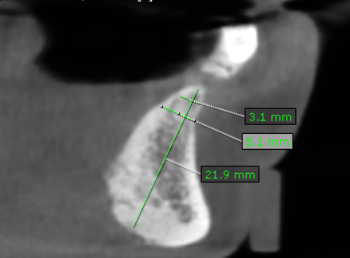
34 region | 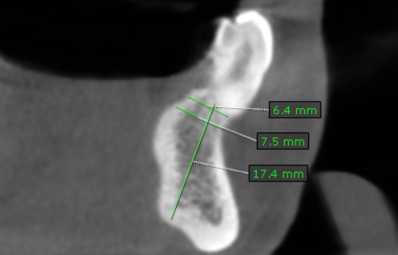
35 region | 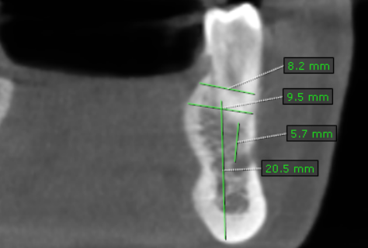
36 region | 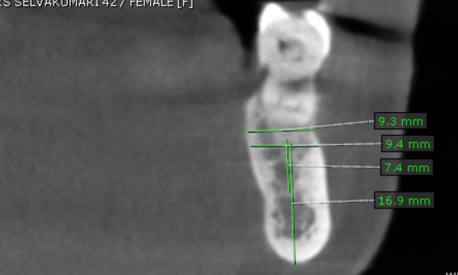
37 region | 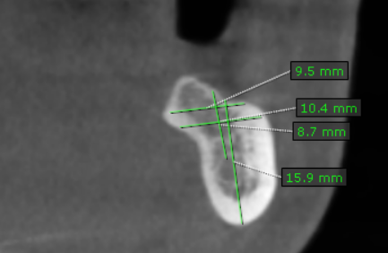
41 region | 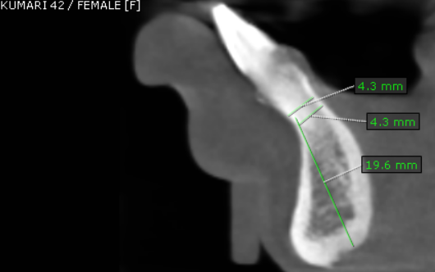
42 region | 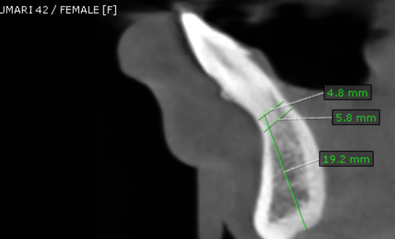
43 region | 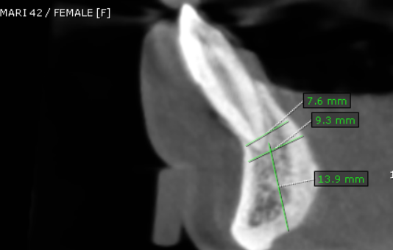
44 region | 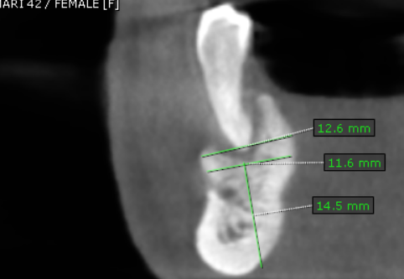
45 region | 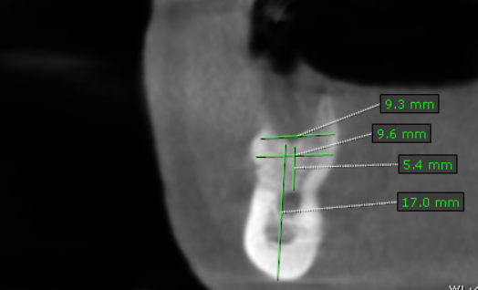
46 region | 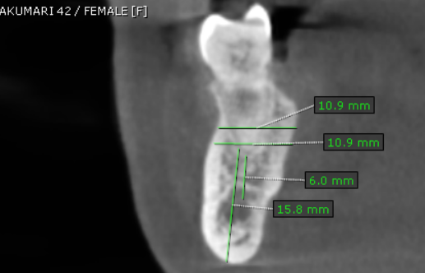
47 region | 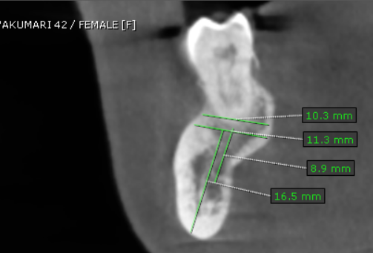

**** End of report ****

